Recursive Add to Source Control Usage Document

IBM provides a tool (a perl script) that can be used to recursively add files inside many folder structures into ClearCase. This script reads through the multiple folder structure, gets each path on to a list and thereby referring each path in a dialog box, and adds the folder/file listed in the path to the source control.

System Requirements for running this tool:

Rational ClearCase
Active Perl

Steps to run the tool (script):

- Copy the script “AddtoSourceControl.pl” from the location \\prithvi\Configuration Management\Development\Source\Script\IBM\Recursive_Add_To_Source_Control to the local drive (C:\ or D:\)

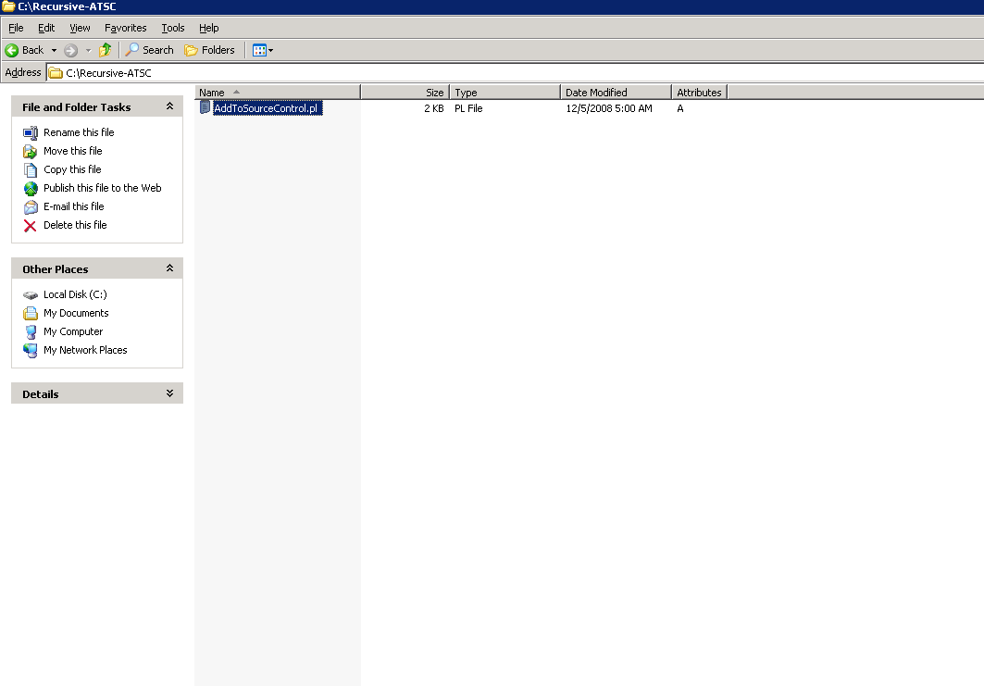

- Copy the main folder (which contains the sub-folders and files inside) to the location of the M:\ drive from Windows explorer.

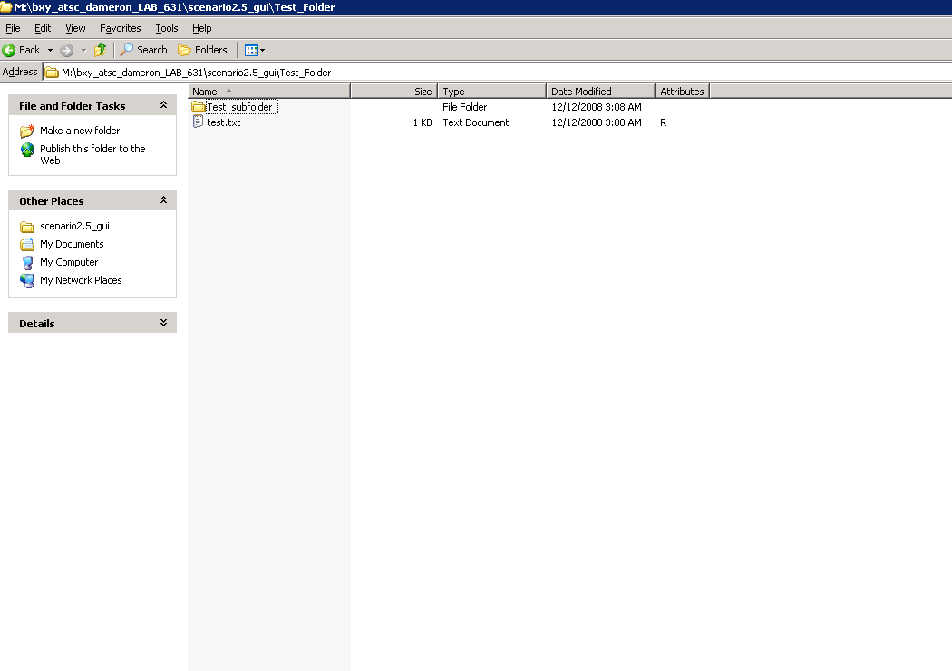

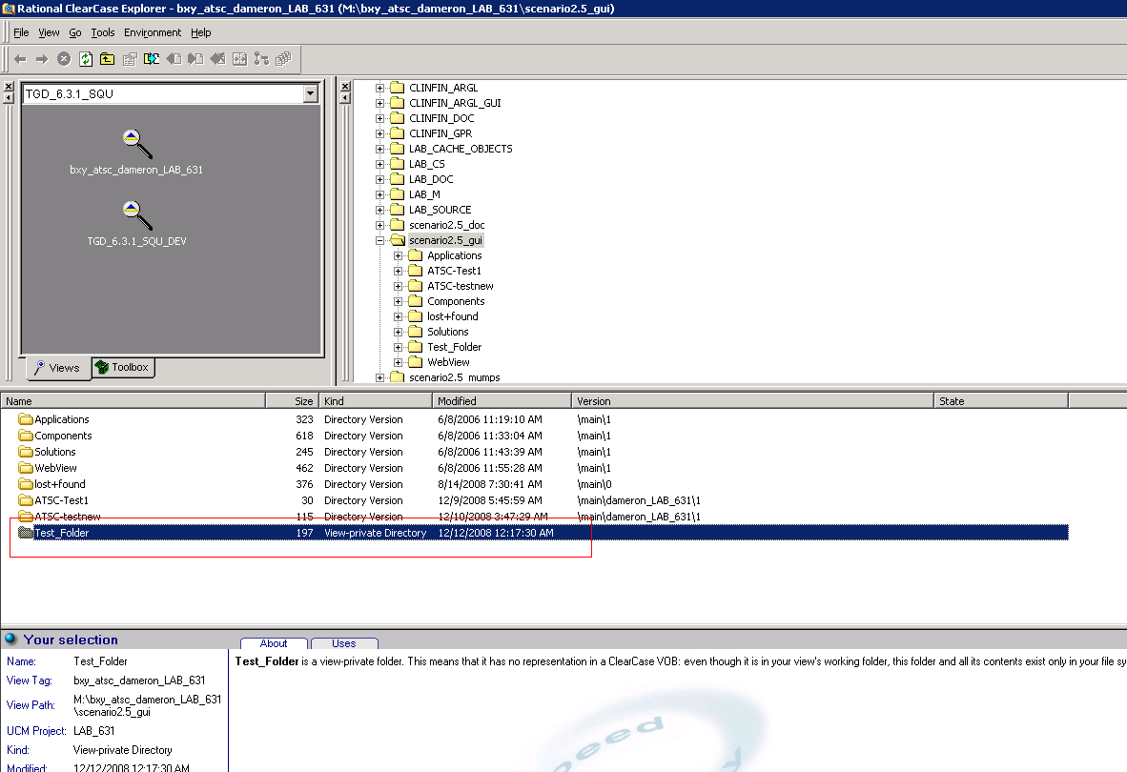

- Run the command as shown below:

The step 3 will prompt for a dialog box.

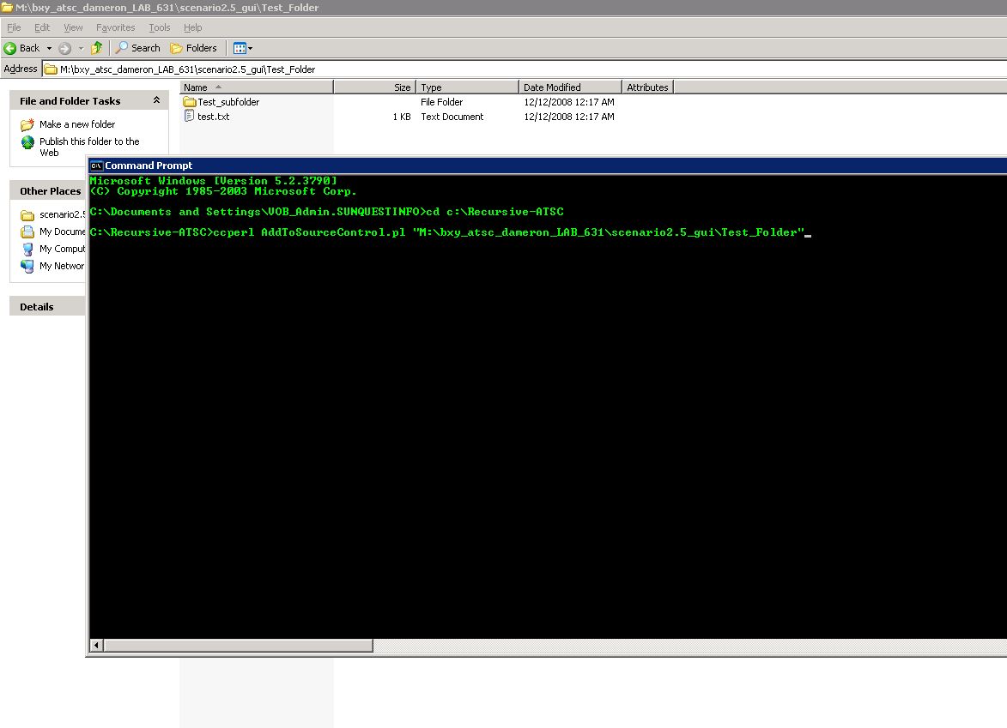

- The dialog box that pops-up contains the list of all the files and folders that it intends to add recursively into source control. Select all and Click Yes.

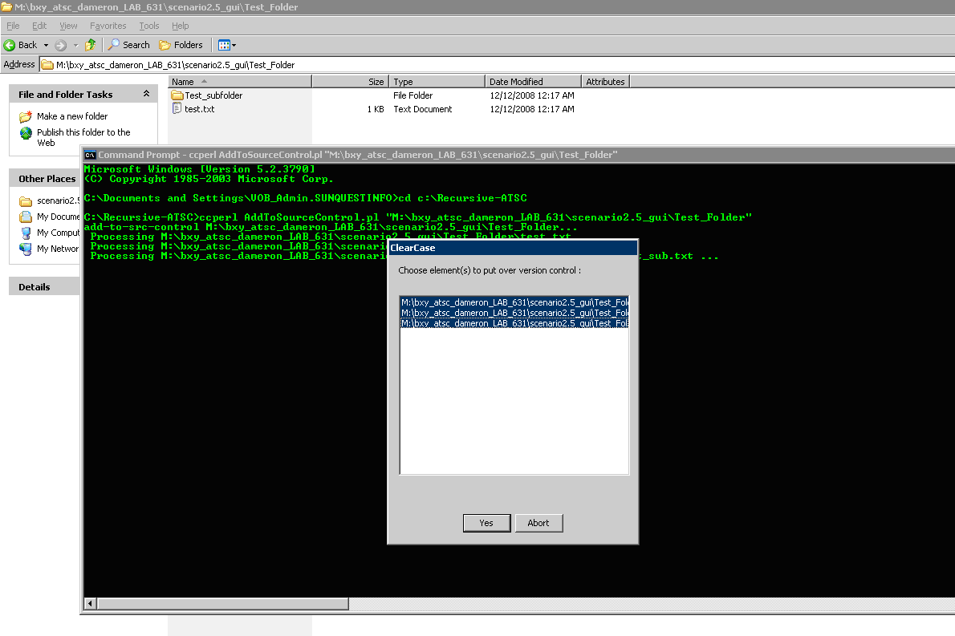

5. It will prompt to create/assign an activity.

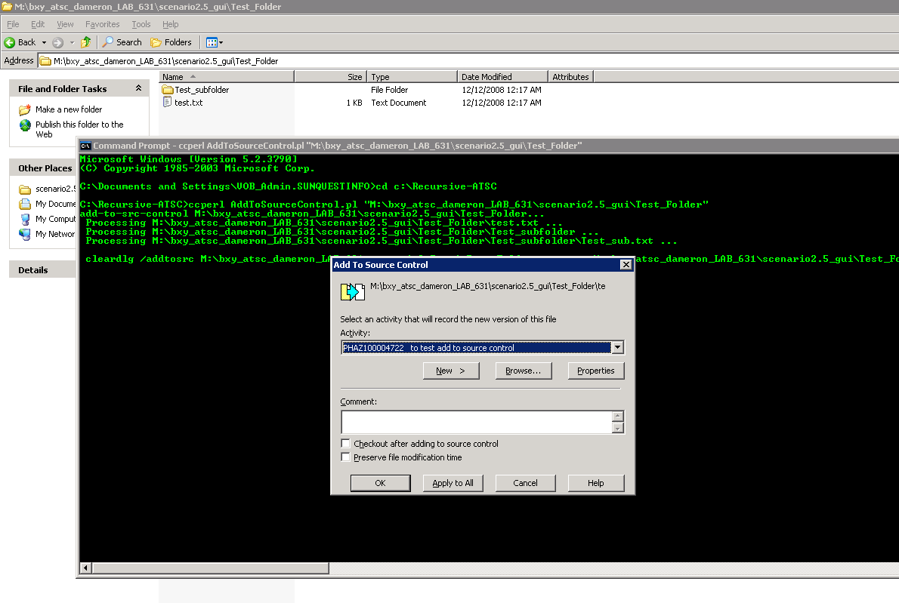

- Clicking “Apply All” in the above step will add all the code to source control recursively.

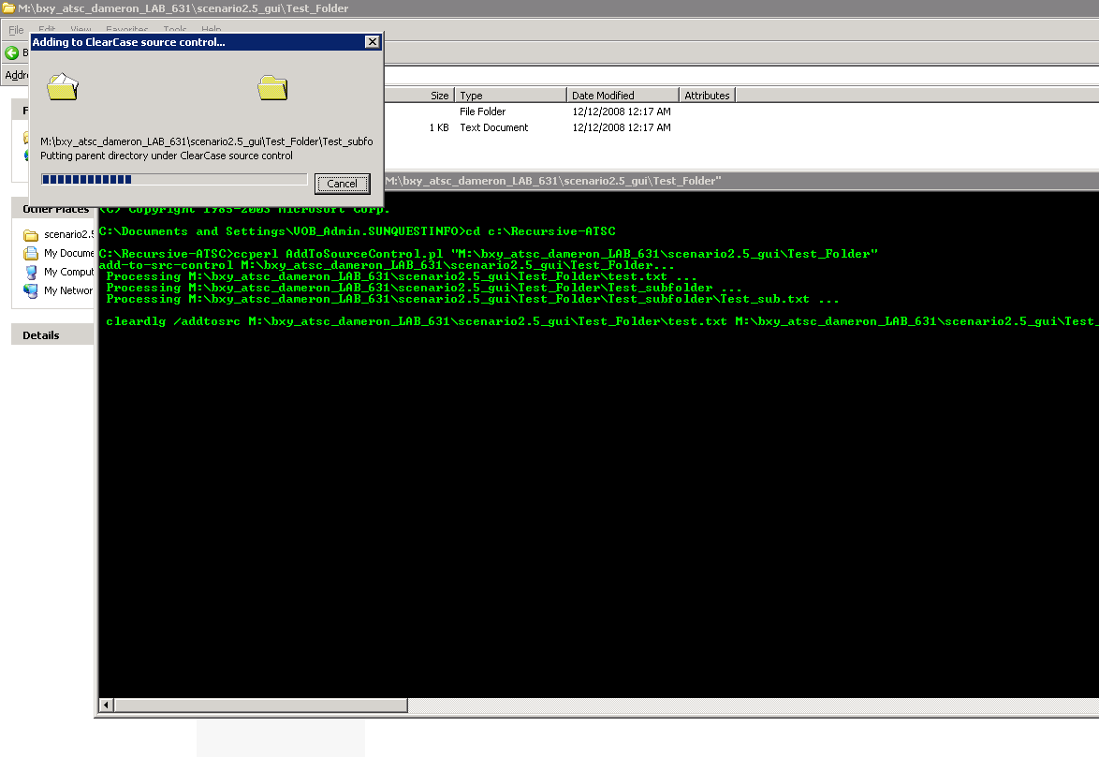

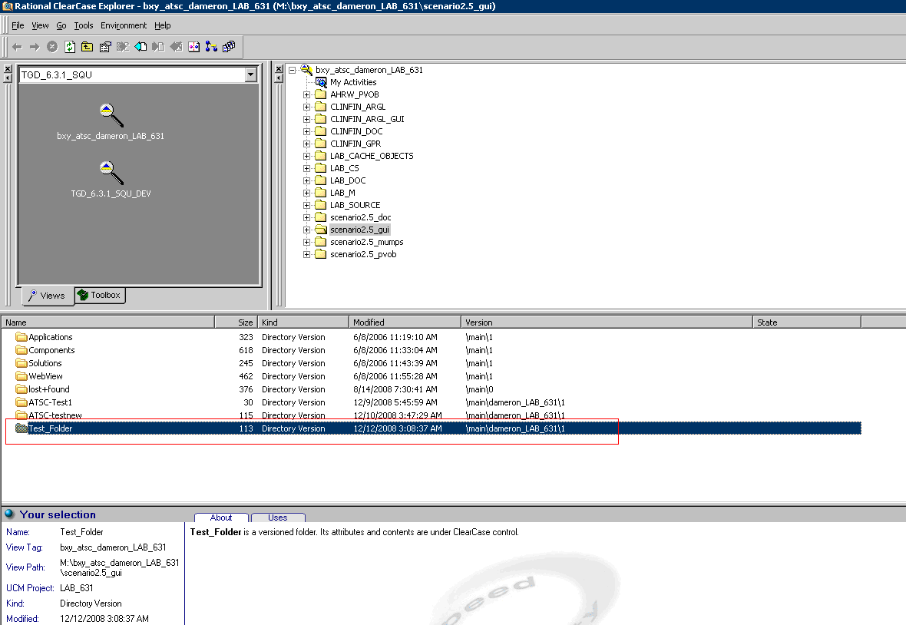
NOTE: We tested the script on the existing folders in ClearCase and the script does not work.

